**ASSIGNMENT 2**

**1.Create user table with username, roll number, email, password QUERY:**

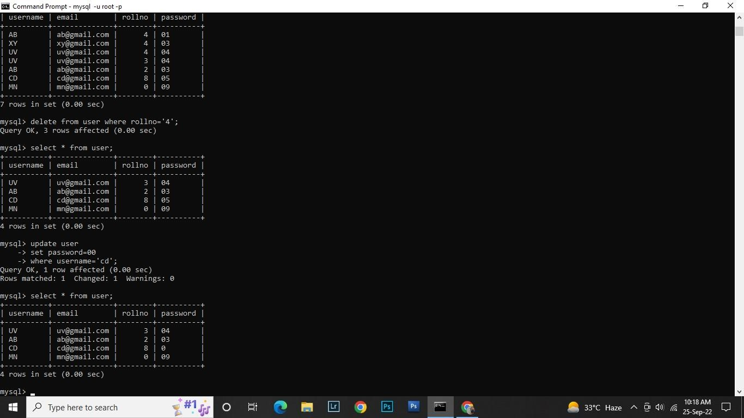

**CREATE TABLE:**

**CREATE TABLE Student (Username varchar (20), email varchar (20), roll number int(15),password varchar(30));**

**INSERT QUERY:**

**Insert into Student values (‘uv’, ‘uv@gmail.com’,’3’,’04’); Insert into Student values (‘AB’, ‘AB@gmail.com’,’2’,’03’);**

**Insert into Student values (‘CD’, ‘CD@gmail.com’,’8’,’05’); Insert into Student values (‘MN’, ‘MN@gmail.com’,’0’,’09’);**

**2.perform UPDATE DELETE queries with user table?**

**QUERY:**

**UPDATE:**

**Update Student set password=00 where username =’CD’;**

**DELETE:**

**Delete from user where roll no =’4’;**



**3.Connect Python code to db2?**

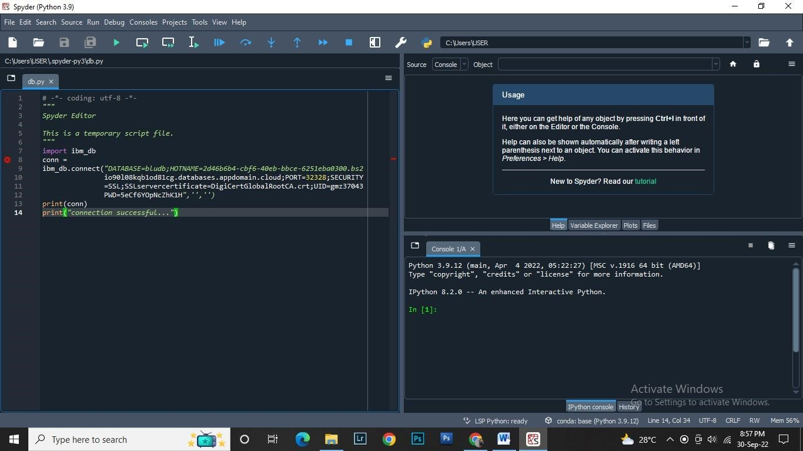

**Question no.4: Create a flask app with registration page login page and welcome page.?**

